Puru Sai Koushik
2200032991
WEEK-4 spring-rest-handson
TASK-3 Hello World RESTful Web Service

HERE WE RUN THE CODE IN THE TERMINAL WITH THE COMMAND
mvn spring:boot:run
we used port 8083
you will see the output on the postman at GET using this link
http://localhost:8083/hello
or you can use the same link on chrome or edge to see the output
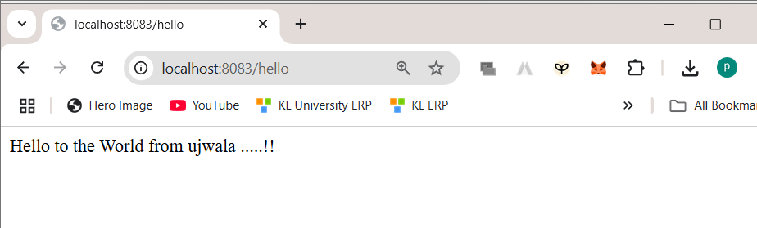
Hellocontroller.java
package com.cognizant.spring_learn.controller;

import org.slf4j.Logger;
import org.slf4j.LoggerFactory;
import org.springframework.web.bind.annotation.GetMapping;
import org.springframework.web.bind.annotation.RestController;

@RestController
public class HelloController {

private static final Logger LOGGER = LoggerFactory.getLogger(HelloController.class);

@GetMapping("/hello")
public String sayHello() {
LOGGER.info("START");
String response = "Hello to the World from ujwala .....!!";
LOGGER.info("END");
return response;
}
}

